Speckey: A Multi-Disease Healthcare Screening Desktop Application Using Machine Learning

Keshav Sharma
Department of Computer Science and Engineering Lovely Professional University
Punjab, India
email address or ORCID

2nd Vivaan Kumar
dept. name of organization (of Aff.) Lovely Professional University Punjab, India
email address or ORCID

Abstract—Screening for chronic conditions at an early stage can ensure appropriate intervention and minimize the clinical risks associated with such conditions. This paper proposes Speckey, a healthcare screening system that integrates machine learning, feature engineering, model evaluation, and user in-teractions into one deployable application. Compared to simple classification scripts, the proposed application accepts patients’ health-related data through its desktop-like dark-colored inter-face and conducts a screening process for several types of disease, namely diabetes, hypertension, and heart disease. During the development of this application, data preprocessing, categorical encoding, computation of health-related features, and ensemble methods were employed to enhance prediction performance of the structured tabular data set used in this study. Various models were implemented during the development, including Logistic Regression, Random Forest, and ensemble model. Among these models, the model deployed in the application is the Random Forest classifier due to its superior performance compared to other models in terms of accuracy, precision, and recall metrics. In addition to predictions, the application offers risk summary of each patient, explanation of prediction based on their features, validation charts of each disease, and visualization of actual vs predicted values.
Index Terms—Keywords: machine learning, healthcare screen-ing, diabetes prediction, hypertension prediction, heart disease prediction, random forest, desktop application, explainable AI

- Introduction
The prevalence of chronic illnesses such as diabetes, hyper-tension, and cardiac disease persists, requiring early diagnosis for proper management of the conditions. Most machine learning projects conducted for educational purposes usually involve training of models and calculation of performance metrics based on one measurement alone. Such an approach may be helpful when learning but fails to demonstrate the real-life implementation process.
This study seeks to create and implement a system that incorporates a wider perspective. The system created here has been named Speckey and refers to a desktop-based These tasks include model training, data preparation, feature selection, reporting, and visualization in one package. The tool was built to be utilized in academic projects, homework assignments, and placements where expertise in software usage is equally as important as expertise in technical skills.
First, it was decided that the project would concern itself only with predictions of diabetes. Then, the scope was ex-
panded in order to incorporate several different diseases into the model, which made it possible to create a prediction tool for diabetes, high blood pressure, and heart disease using just one form for a patient intake.

- Related Work

In predictive analysis, machine learning models are utilized in many applications due to the structured format of the dataset, including numeric and categorical data suitable for classification modeling techniques. Logistic Regression acts as the basis for modeling, providing simplicity and interpretabil-ity. For healthcare structured data, Random Forest is one of the models widely used, demonstrating proficiency in detecting non-linear correlations among variables.
In predicting health outcomes, several researchers empha-size the importance of considering more than accuracy when evaluating the performance of models. Measures such as precision, recall, F1 score, ROC-AUC, and confusion matrix play vital roles in disease prediction applications, given that the consequences of false-positive and false-negative rates vary considerably in such instances. Additionally, current project-oriented studies pay special attention to model explainability and easy-to-use interfaces.

- Proposed System Architecture

Speckey’s proposed system architecture may be described using the concept of a six-stage pipeline:
- Dataset Loading – This is the first step that concerns data input.
- Preprocessing & Data Cleaning – This stage deals with cleansing of the data being loaded.
- Feature Engineering – In this process, suitable features are extracted or generated.
- Model Training & Disease-wise Screening – At this point, model training takes place as well as disease-based screening.
- Evaluation & Visualization – Performance evaluation takes place as results are visualized.
- Desktop Application Deployment – Finally, the system is deployed as a desktop application.

- Dataset
In this case, we use a healthcare dataset containing almost 100,000 patients’ profiles. The dataset consists of demo-graphic information and medical variables such as gender, age, hypertension, heart disease, smoking history, Body Mass Index (BMI), HbA1c, blood glucose level, and diabetes. The chosen dataset can be used for multi-target screening since it already includes various disease labels, including diabetes, hypertension, and heart diseases. Instead of feeding the labels for diseases into the model, the deployed application will use a common patient profile and utilize a specific model to screen the risk of contracting these diseases.
- Data Preprocessing
In the first stage of data preparation, we perform several vital tasks such as importing the dataset, identifying the target columns, and distinguishing between the common patient fea-tures and disease labels. This way, the proper data structuring can be guaranteed for further usage in machine learning algorithms. In the model training process, the handling of missing and invalid values takes place through imputation. For categorical variables, the one-hot encoder will be utilized, whereas the median imputation algorithm will be applied to numerical variables before the actual training begins.
- Feature Engineering
To improve model quality, the project derives several addi-tional features from the raw dataset, including:
  - Age–BMI interaction
  - Glucose–HbA1c interaction
  - Glycemic-load indicator
  - Cardiovascular-risk count
  - Smoking-risk grouping
  - BMI-category banding
These engineered features are designed to highlight clini-cally significant relationships that might not be strongly appar-ent in individual raw columns. Furthermore, they increase the practical value of the project by demonstrating that the pipeline is capable of more than just direct CSV-to-model training.
- Model Design
During development, three model strategies were explored: Logistic Regression: This method was chosen as a robust baseline due to its inherent interpretability and effectiveness in tabular classification scenarios.
Random Forest: This model consistently demonstrated a superior balance for the primary Diabetes target, improving recall and F1-score while maintaining high degrees of both accuracy and precision.
Soft Hybrid Voting Ensemble Approach: This technique provided better precision in some specific cases of comparison. In the end, Random Forest has been selected as the more practical solution to use. Random Forest was found to provide more balanced screening results when compared to the soft hybrid voting ensemble approach despite the fact that the latter provided some marginal precision improvements in certain cases.
- Desktop Application Layer
Machine Learning Back-end Integration The machine learn-ing back-end technology is incorporated within a Tkinter application. The Graphical User Interface includes:
  - Local login and demo-account dashboard display
  - Patient evaluation module
  - Validation center
  - About screen
In order to provide a professionally looking interface during demonstrations, the interface uses a sophisticated combination of colors black, gold, and white. The interface also uses visual representations of information using such tools as disease tiles, risk gauges, disease summary cards, and validation.
- Application Screens

This version of Speckey includes a desktop login page, an executive dashboard, and a patient screening workspace. These screens are displayed below as part of the executed system.
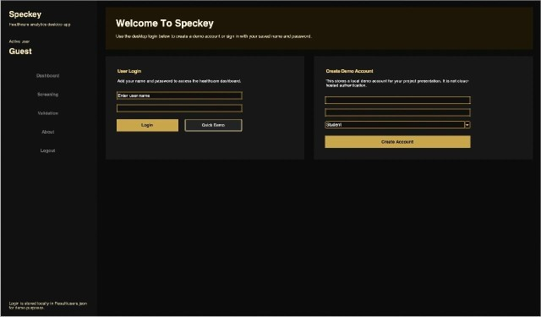
Fig. 1. Login and demo account creation screen of the Speckey desktop application.
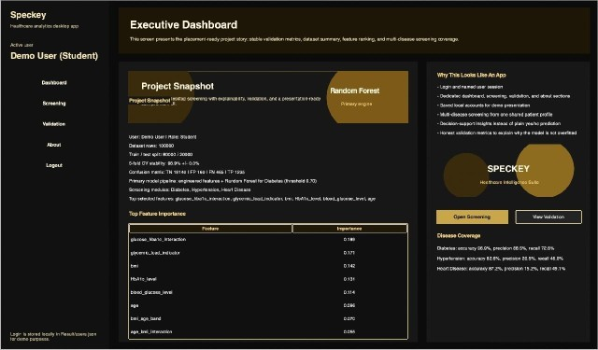

Fig. 2. Executive dashboard showing project summary, selected model, feature importance, and disease coverage.

- Experimental Setup
The system is designed by utilizing Python programming language, with help of libraries such as Pandas, NumPy, scikit-learn, and Tkinter. To ensure that labels’ distribution is kept intact, the data has been split into train and test datasets using stratification technique. Prior to fitting, feature engineering processes have been applied. The current model used in the system is Random Forest classifier.
The model validation utilizes:

  - Accuracy, precision, and recall
  - F1-score
  - ROC-AUC
  - Confusion matrix
  - Cross-validation for the main disease model
In addition to metrics display, a visual interpretation of the differences between predicted and actual outputs has been provided within the application validation module. It is imple-mented using a bar graph and confusion matrix visualization, allowing to understand the model operation.
- Results and Discussion
- Comparative Model Results for the Primary Diabetes Target: The main model comparison conducted during devel-opment is summarized in Table I.

TABLE I
Performance of Classification Models

Model Accuracy Precision Recall F1-score ROC-AUC
Logistic Regression 96.22% 90.76% 61.82% 73.55% 96.22%
Random Forest 97.02% 93.88% 69.53% 79.89% 97.58%
Hybrid Ensemble 97.02% 96.55% 67.41% 79.39% 97.59%

Fig. 3. Model comparison for the primary diabetes screening task.

Table I indicates that Random Forest exhibits the most favorable equilibrium across the primary classification metrics. While Logistic Regression serves as a useful baseline due to its interpretability, it yields lower recall. The hybrid ensemble demonstrates exceptionally high precision, although its recall is marginally surpassed by Random Forest. Consequently, for an application focused on balanced screening, Random Forest emerges as the preferred final model.
- Multi-Disease Extension: The project has taken a step further to incorporate more diseases apart from diabetes in the classification algorithm. At present, besides diabetes, the algorithm has been designed to check for hypertension and heart disease based on the patient’s information provided during the intake process. This development greatly increases the efficiency of the algorithm by showing how a particular clinical space is efficiently utilized in different diseases. Under the validation tab of the GUI, one will be able to view performance summaries for all the diseases checked for.
- Discussion: As such, the results obtained from this project clearly show that accuracy alone is not enough when evaluating healthcare screening models. High precision of the model cannot guarantee good results in finding positive cases when its recall rate is poor. On the other hand, a model focused on maximizing its recall could lead to too many false positives. Overall, this means that model evaluation should be viewed through the lens of balance, rather than just accuracy.
Another key aspect worth considering is the evident im-provement in the quality of the project resulting from increased usability. Indeed, adding a desktop interface, logging-in pro-cedure, disease overview, validation graphs, and explanations greatly improves its presentation and justifications at both viva
voce and placement interviews. In this regard, it can be said that one of the key strengths of the Speckey application lies in its fully-fledged nature.
Conclusion
This paper presented the Speckey software, which was designed as a desktop application to carry out healthcare screening for multiple diseases. It was created based on machine learning and implemented using Python programming language. It includes such elements as pre-processing, feature engineering, model selection, disease screening, explainability, report generation, and interface. Experiments showed that the most efficient algorithm used in this software is Random For-est, since it provides the best balance between the parameters such as accuracy, precision, recall, and F1-score in terms of diabetes screening in particular. This paper demonstrates how machine learning project can be transformed into actual software solution, stressing that its quality depends not only on the performance of the model, but also on many other factors.
Future Scope
Persistence Model Caching: Use persistence model caching to greatly improve application start-up times.
Export Screening Report as PDF: Include the capability to export screening reports as a PDF for improved readability and portability.
Managing Patient Information: Provide facilities for manag-ing patient information through comprehensive patient history management and record management.
Application Web Deployment: Support web deployment of the application to ensure remote accessibility of the tool.
Disease Module Development and Rich Datasets: Develop more disease modules for the application and enrich the application using rich datasets.
Incorporation of Explainability: Introduce explainability methods such as SHAP based explanations for interpreting predictions made by models.
- References
References
- F. Pedregosa et al., “Scikit-learn: Machine Learning in Python,” J. Mach. Learn. Res., vol. 12, pp. 2825–2830, 2011.
- W. McKinney, “Data Structures for Statistical Computing in Python,” in Proc. 9th Python in Science Conf., 2010, pp. 56–61.
- C. R. Harris et al., “Array programming with NumPy,” Nature, vol. 585,
pp. 357–362, 2020.
- Python Software Foundation, “tkinter — Python interface to Tcl/Tk,” Python Documentation, 2023.
- L. Breiman, “Random Forests,” Machine Learning, vol. 45, no. 1, pp. 5–
32, 2001.

